**Type of the Paper (Research, Review, Communication, etc.)**

**TITLE (Maximum 10 Words)**

Firstname Lastname a ORCID, Firstname Lastname b ORCID and Firstname Lastname b,* ORCID (Open Researcher and Contributor ID) for authors, freely available at [https://orcid.org](https://orcid.org/). (Why is this important? Your article, if accepted and published, will be attached to your ORCID profile. Institutions and funders are increasingly requiring authors to have ORCID IDs.))

**a** Affiliation 1 (including full address); [e-mail@e-mail.com](mailto:e-mail@e-mail.com)

b Affiliation 2 (including full address); [e-mail@e-mail.com](mailto:e-mail@e-mail.com)

**\*** Corresponding author: e-mail@e-mail.com; Tel.: (optional; include country code)

**Structured Abstract (150-250 words)**

*Purpose*: purpose of the study.

*Design/methodology/approach*: Describe the research method used.

*Findings:* Summarize key findings.

*Research limitations/implications:* If applicable, outline limitations.

*Practical implications*: If applicable, mention the practical applications of this research.

*Social implications*: If applicable, discuss the societal impacts.

*Originality/value*: Explain how this research contributes to the field.

**Keywords**: Keyword 1, Keyword 2, Keyword 3, Keyword 4, Keyword 5 (specific to the article yet reasonably common within the subject discipline.)

***Suggested standard structure of the body of research manuscripts***

**1. Introduction (≈ 30% of manuscript)**

Provide an outline of the research area, problem or issue, its scope, aims, and hypotheses. Include a critical review of existing studies. Clearly state what was done and why.

**2. Methods and Materials (≈ 15% of manuscript)**

Describe the research design, data collection, and analysis techniques. Explain why this approach was chosen.

**3. Results (≈ 20% of manuscript)**

Present the key findings of the study in an objective manner. Include figures and tables as necessary.

3.1. Subsection

3.1.1. Subsubsection

Bulleted lists look like this:

• First bullet;

• Second bullet;

• Third bullet.

Numbered lists can be added as follows:

1. First item;

2. Second item;

3. Third item.

The text continues here.

3.2. Figures, Tables and Schemes

All figures and tables should be cited in the main text as Figure 1, Table 1, etc. prior to their appearance in the text

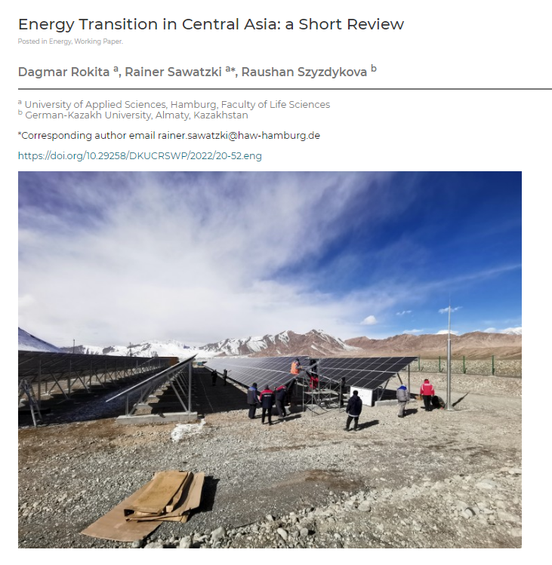

**Figure 1.** This is a figure. Schemes follow the same formatting. Source:

**Table I.** Title.

|  |  |  |
| --- | --- | --- |
| **Title 1** | **Title 2** | **Title 3** |
| entry 1 | data | data |
| entry 2 | data | data |

Footnote. Source:

**4. Discussion (≈ 20% of manuscript)**

Interpret the results, compare them with previous research, highlight their significance, and discuss any limitations.

**5. Conclusion (≈ 5% of manuscript)**

Summarize the key findings, their implications, and potential future research directions.

**6. Acknowledgments (if applicable)**

Mention any financial support, funding sources, or individuals who contributed but are not listed as authors.

**7. References (≈ 10% of manuscript, APA style, in alphabetic order). References cited in text must appear in the reference list and vice versa.**

References must be formatted in [**APA style**](https://apastyle.apa.org/style-grammar-guidelines/references/examples/published-dissertation-references) and checked for accuracy and completeness. At least **4-5 sources of Scopus and/or Web of Science** should be included and marked by * sign in the list of references.

**Journal’s article:**

Author 1, A.B.; Author 2, C.D. Title of the article. *Abbreviated Journal Name,* Year, Volume, page range.

***Example:*** Grady, J. S., Her, M., Moreno, G., Perez, C., & Yelinek, J. (2019). Emotions in storybooks: A comparison of storybooks that represent ethnic and racial groups in the United States. *Psychology of Popular Media Culture*, 8(3), 207–217. https://doi.org/10.1037/ppm0000185

**Book:**

Author 1, A.B. Title of the Book, Edition; Publisher: Year. <https://doi.org/DOI>

***Example:*** Jackson, L.M. The Psychology of Prejudice: From Attitudes to Social Action, 2nd ed.; American Psychological Association: 2019. <https://doi.org/10.1037/0000168-000>

**Chapter in a book**

Author 1, A.B.; Author 2, C.D. Title of the chapter. In Title of the Book, Edition; Editor(s), E.F., Ed.; Publisher: Year, Page range.

***Example:*** Jackson, L.M. Stereotypes and Discrimination. In The Psychology of Prejudice: From Attitudes to Social Action, 2nd ed.; American Psychological Association: 2019, pp. 45–67. <https://doi.org/10.1037/0000168-000>

**Websites:**

**Author or Organization Name.** (Year, Month Day). Title of the webpage. Website Name. URL

***Example:*** American Psychological Association. (2019). Understanding prejudice and discrimination. <https://www.apa.org/topics/racism-bias-discrimination/types-stereotypes>xampleAPA format (7th edition)

**Newspaper articles**

Author(s). (Year, Month Day). Title of the article. Title of the Newspaper, page(s).

***Example:*** Smith, J. (2023, October 15). Climate change impact on coastal cities. The New York Times, A1, A4.

**Conference proceedings**

Author(s). (Year). Title of the paper. In Editor(s) (Eds.), Title of the conference proceedings (pp. page range). Publisher. <https://doi.org/DOI>

***Example:*** Brown, K. A., & Green, L. T. (2022). Machine learning applications in climate modeling. In R. Smith & J. Doe (Eds.), Proceedings of the International Conference on Climate Change Research (pp. 112–125). Springer. https://doi.org/10.xxxx

**Report by Government Agency**

Government Agency. (Year). Title of the report (Report Number if available). Publisher. URL

***Example:*** World Health Organization. (2021). Global status report on road safety 2021. <https://www.who.int/publications/i/item/9789240039651>

**Russian sources in APA format with transliteration via** [**https://translit.ru/**](https://translit.ru/)**:**

Author(s). (Year). Title in transliteration [English translation]. Transliterated Journal title [English translation of the journal’s title], Volume(Issue), page range. <https://doi.org/DOI>

***Example:*** Petrova, A. S. (2019). Klimaticheskie izmeneniya v basseine Amudaryi [Climate changes in the Amu Darya Basin]. Vestnik Prirodopolzovaniya [*Bulletin of Nature Management],* 25(3), 45-58. https://doi.org/xxxx

**Formatting of “In-text citations”:**

Quoting directly:

The CEO stated clearly that co-op students “needed manager’s permission to access the company’s data warehouse” (Smith 2010, p.15).

Quoting indirectly:

*Single author*

Smith (2010) reported that 20% of Canadians have a language other than English or French as their mother tongue.

It has been found that Canadians drink 7 cups of coffee a week on average (Susan, 2010).

*Two authors*

The study went on to show a difference between these MBA programs (Smith & Susan, 2009).

*Three and more authors*

Recent research shows that university students report that Facebook is the number one distraction from study time (Graham et al., 2010).

**Author Contributions:**

Detailed information about the specific contributions of every author should be provided. Please list all authors with their initials.  
*Example of Author Contributions statement:*  AB and DJ conceived and supervised the study; AB and KL designed experiments; KL, DG and DGN performed experiments; AG provided new tools and reagents; KG developed new software and performed simulation studies; KL and DGN analysed data; KL, AB and DJ wrote the manuscript; KL and AB made manuscript revisions.

**Figures and Tables Formatting**

* **Figures**
  + Figures should be in **editable formats** such as **.tif, .jpeg, .bmp** (at least **10 cm wide, min 150 dpi**).
  + Figures may be **embedded in the manuscript,** and **submitted separately upon request**.
  + Figures must have **labels for all symbols and abbreviations**.
  + Captions should be formatted as follows:
    - **Figure 1.** Title of the Figure (below the figure, centered, 12 pt)
    - **Figure 2.** Title of the Figure
* **Tables**
  + Tables should be in **editable text**, not images.
  + Tables can be placed **within the text** or at the end of the manuscript as an appendix.
  + Captions should be formatted as follows:
    - **Table I.** Title of the Table (above the table, left-aligned, 12 pt)
    - **Table II.** Title of the Table
  + Superscripts and footnotes should be listed below the table.

**Formatting Requirements**

* **File format**: Microsoft Word (.docx)
* **Font**: Times New Roman, 12 pt, 1.5 line spacing, justified alignment
* **Title**: Bold, Centered, 12 pt
* **Headings**: Sentence case, bold, numbered (e.g., 1., 2., 3.)
* **Subheadings**: Italicized, numbered (e.g., 2.1., 2.2.)
* **Text alignment**: Justified
* **Line numbering**: Continuous throughout the document